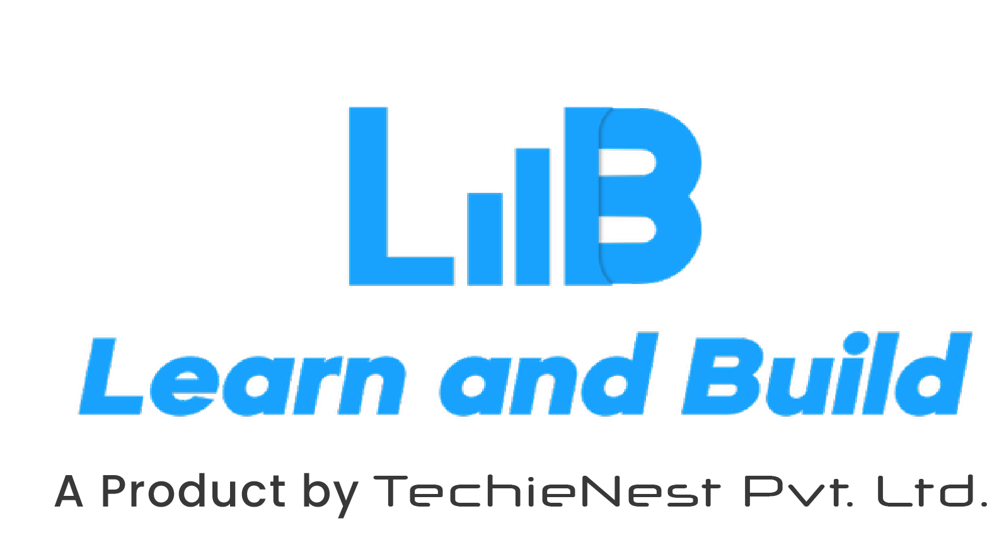

**Roadmap for Summer Internship Program 2025**

Congratulations our dear intern,

We welcome you to our growing energetic family!

Our exclusive **Summer Internship Program** is divided into 3 phases, and the following are the checkpoints that you will go through in your overall journey:

1. Pre-Internship Phase
   1. Assessment 1: Give the post-assessment test so as to evaluate your domain understanding after the course completion
2. During Internship Phase
   1. You will be allotted to a domain group of interns from various institutions across the world
   2. Your group will be allotted with domain experts so as to provide you with a structured mentorship
   3. Project: Multiple projects and tasks will be allotted to you which you will be required to complete over the span of the internship (the duration selected by you while filling the internship form – 15/30/45/60 days)
   4. Assignments & Projects: You have to complete your assignment & projects before the stipulated deadline
3. After Internship Phase
   1. Certificates will be awarded to the interns and they will be given an opportunity to participate in job-a-thon